**GROCERY STORE OBJECT DETECTOR**

**Submitted for**

**Statistical Machine Learning CSET211**

Submitted by:

**(E23CSEU2234) Manash Khandelwal**

**(E23CSEU2233) Raghav Garg**

**(E23CSEU2226) Akshat Saini**

Submitted to

**DR. SHAKSHI SHARMA**

**July-Dec 2024**

**SCHOOL OF COMPUTER SCIENCE AND ENGINEERING**

**INDEX**

|  |  |  |
| --- | --- | --- |
| Sr.No | Content | Page No |
| 1. | Abstract | 3 |
| 2. | Introduction | 3 |
| 3. | Related Work | 3-4 |
| 4. | Methodology | 4 |
| 5. | Hardware/Software Required | 5 |
| 6. | Experimental Results | 6 |
| 7. | Conclusion | 9 |
| 8. | Future Scope | 10 |
| 9. | GitHub Link of Your Complete Project | 10 |

1. **Abstract**

**This project introduces a Grocery Store Object Detector, developed using YOLOv8s, designed to identify grocery store items in real-time. The model detects 24 predefined grocery products using a robust object detection framework. It is hosted locally via a Flask-based web interface, where users can upload images to detect and return identified objects. The project aims to simplify the checkout process in grocery stores, potentially allowing store employees to scan and bill entire carts efficiently using their smartphones. The dataset for this project was sourced from Roboflow, with extensive training and testing to ensure accuracy. Experimental results validate the model's capability to identify products effectively, laying the foundation for future deployment in real-world retail environments.**

1. **Introduction**

* **Background: The grocery shopping experience often involves lengthy checkout processes, requiring manual scanning of items. Automating this process can save time and improve efficiency.**
* **Objective: To create an object detection system that identifies grocery items from an image, enabling faster billing processes in retail environments.**
* **Significance: The system can revolutionize the retail industry, paving the way for cashier-less checkouts and streamlined inventory management.**

1. **Related Work**

**The application of computer vision and object detection in retail has been an area of active research and development. Several projects and systems serve as foundational or comparable references to this Grocery Store Object Detector:**

* **Automated Checkout Systems:**
  + **Companies like Amazon Go have pioneered cashier-less stores using advanced computer vision, sensor fusion, and machine learning. These systems automatically detect items customers pick up, streamlining the checkout process.**
  + **Unlike this project, which focuses on affordable solutions using YOLOv8s and smartphones, such systems often require extensive infrastructure and high implementation costs.**
* **Object Detection with YOLO:**
  + **The YOLO (You Only Look Once) family of models has been widely adopted for object detection tasks due to its speed and accuracy.**
  + **Previous implementations, such as detecting products in warehouses or inventory systems, highlight YOLO's efficiency in structured environments similar to grocery stores.**
* **Barcode Scanning Systems:**
  + **Traditional retail checkout relies heavily on barcode scanners for item identification.**
  + **While effective, these systems are limited by their inability to recognize unlabeled or damaged products. Object detection models offer a more robust solution by directly identifying items visually.**
* **Roboflow and Dataset Management:**
  + **Platforms like Roboflow have enabled efficient dataset curation and preprocessing for object detection.**
  + **The dataset used for this project was sourced from Roboflow's Grocery Dataset, a curated collection of labeled grocery images designed to train object detection models.**
* **Comparative Systems in Research:**
  + **Several academic studies have explored item recognition in retail settings, focusing on detecting cluttered or overlapping objects.**
  + **This project builds on such work by applying the YOLOv8s framework for increased accuracy and deploying the system through a web-based interface for practical use.**

**While existing systems provide valuable insights, the Grocery Store Object Detector distinguishes itself by aiming for affordability, accessibility, and ease of deployment, targeting small and medium-sized retailers. This approach fills a gap in the market for scalable, low-cost solutions that can enhance retail efficiency without requiring significant infrastructure investment.**

1. **Methodology**
2. **Dataset Collection:**

• Dataset sourced from [Roboflow](https://universe.roboflow.com/new-workspace-wfzw3/grocery-dataset-q9fj2).

(<https://universe.roboflow.com/new-workspace-wfzw3/grocery-dataset-q9fj2>)

• Preprocessing steps: Data augmentation, normalization, and splitting into training, validation, and testing sets.

1. Model Training:

* YOLOv8s architecture was selected for its speed and accuracy.
* Configuration details: learning rate, epochs, batch size, etc.

1. Testing:

* Evaluation metrics: Precision, recall, F1 score.
* Use of glob to automate image testing.

1. Web Application Development:

* Backend: Flask for API endpoints.
* Frontend: HTML/CSS for the upload interface.

1. Deployment:

* Local hosting for initial testing, with plans for cloud deployment.

1. **Hardware/Software Required**

* **Hardware:**
* **High-performance GPU (e.g., NVIDIA RTX 3080) for model training.**
* **Laptop or smartphone with a camera for deployment.**
* **Software:**
* **• Python 3.8 or above.**
* **• YOLOv8s framework.**
* **• Flask for backend development.**
* **• Libraries: OpenCV, Numpy, Pandas, Glob, etc.**
* **Dataset platform: Roboflow.**

1. **Experimental Results**

* **Model Performance:**

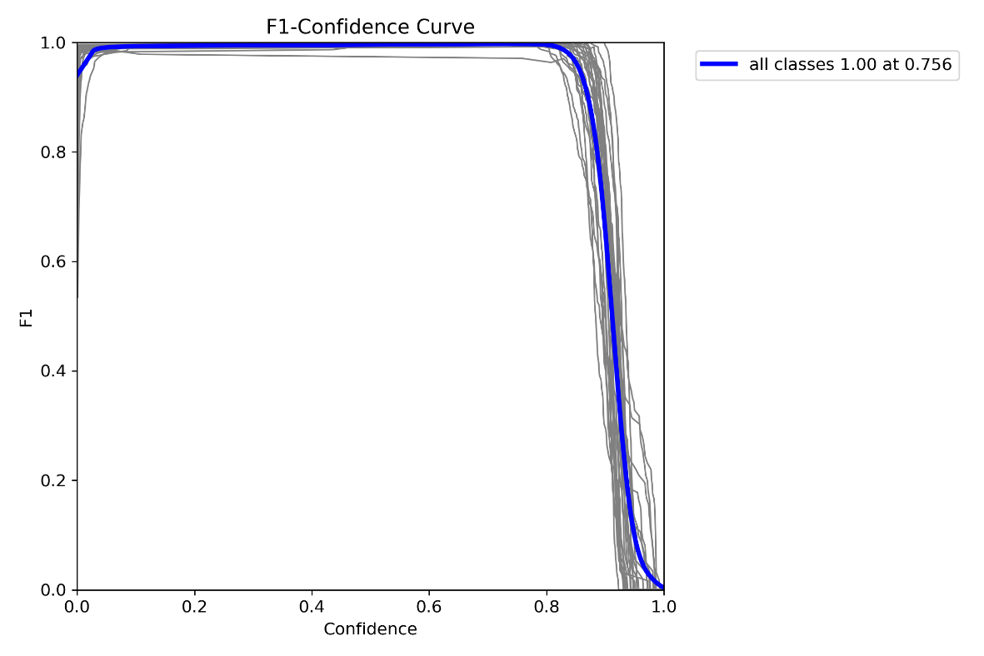

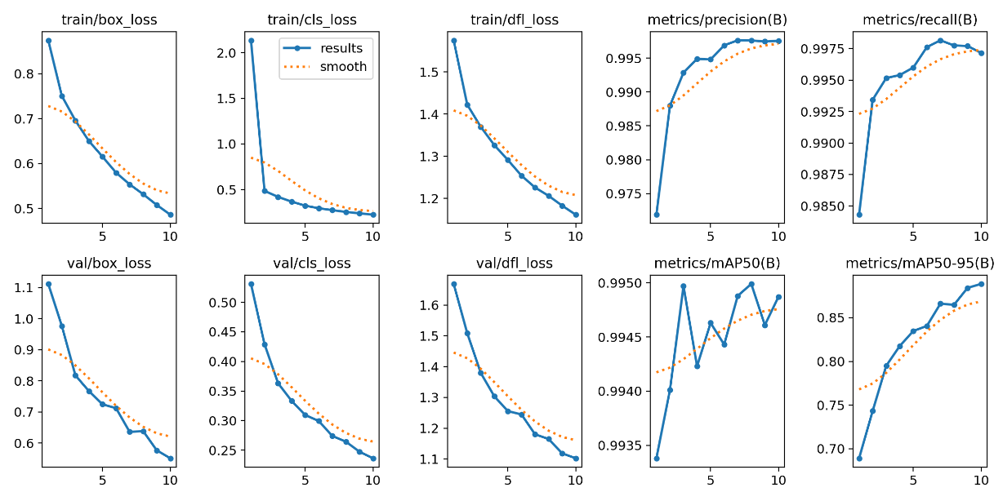

* **Qualitative Results:**

* **Website Demonstration:**

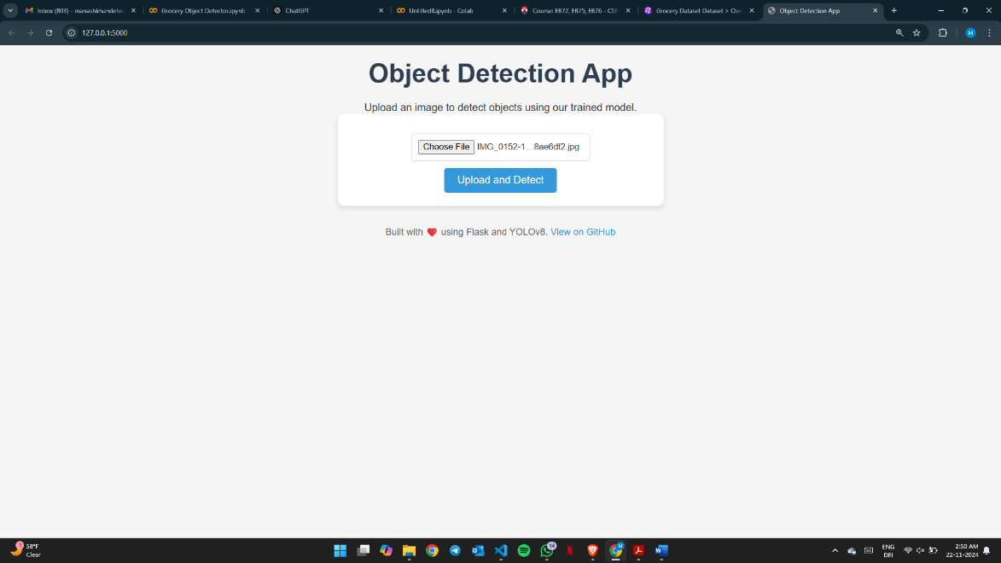

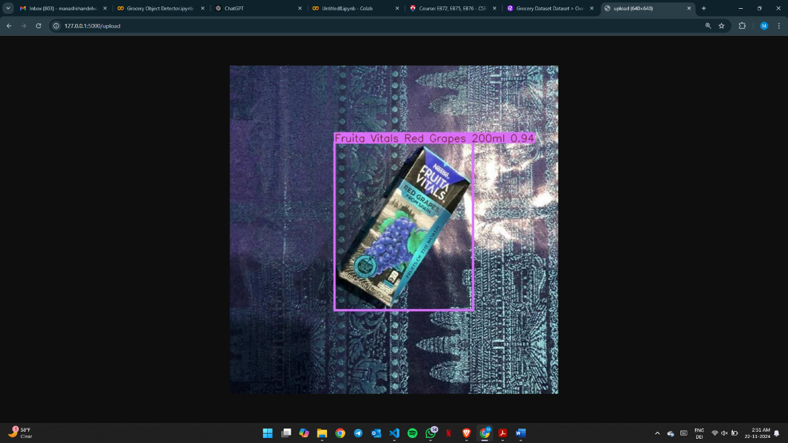

1. **Conclusions**

**The Grocery Store Object Detector project successfully demonstrates the use of computer vision techniques to streamline the retail checkout process. By employing the YOLOv8s model, the system effectively identifies 24 specific grocery items with high accuracy and speed. Hosted on a Flask-based web platform, the solution allows users to upload images and receive detected results instantly, showcasing its potential for practical deployment in grocery stores.**

**This project addresses the growing need for automation in retail by offering a scalable, cost-effective solution that could enhance operational efficiency and improve the customer experience. While the model performs well in controlled environments, some limitations remain, such as difficulty detecting objects in crowded or poorly lit scenes. Addressing these challenges, along with expanding the dataset to include a broader range of products, will be critical steps for future development.**

**Looking ahead, the integration of this system with mobile applications and Point-of-Sale (POS) systems could revolutionize the checkout process, enabling seamless cart-based billing. The broader implications extend beyond retail, as the methodology could be adapted for inventory management, automated sorting, and other applications. This project marks an important step toward realizing the vision of automated, AI-driven retail experiences.**

1. **Future Scope**

* **Mobile App Integration: Develop a smartphone app for portable and user-friendly object detection, enabling real-time scanning of items.**
* **Expanded Dataset: Increase the variety of detectable grocery items, ensuring global adaptability and inclusion of diverse product ranges.**
* **POS Integration: Connect the system with Point-of-Sale (POS) systems for instant billing, receipt generation, and automated inventory updates.**
* **Real-Time Detection: Implement live video feed processing to detect items dynamically as they are added to a cart, streamlining the checkout process.**
* **Scalability and Deployment: Deploy the system on cloud platforms for wider accessibility and scalability while exploring cost-effective hardware for small retailers.**

1. **GitHub Link of Your Complete Project**

https://github.com/manashkhandelwal/Grocery-Store-Object-Detector

**THANK YOU :)**